1. Several ports (8005, 8080, 8009) required by Tomcat v5.5 Server at localhost are already in use. The server may already be running in another process, or a system process may be using the port. To start this server you will need to stop the other process or change the port number(s).

解决方法：

查看当前端口占用情况，然后打开任务管理器对对应pid的程序进行强行关闭。

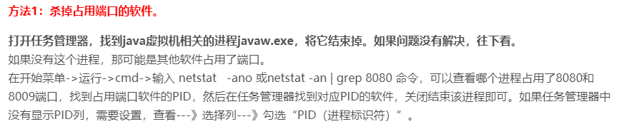

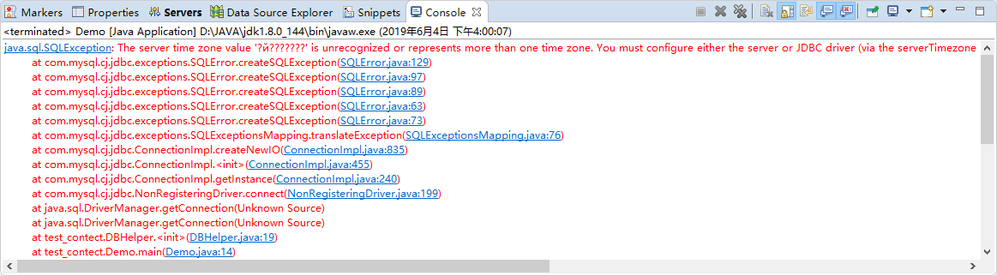

解决办法：

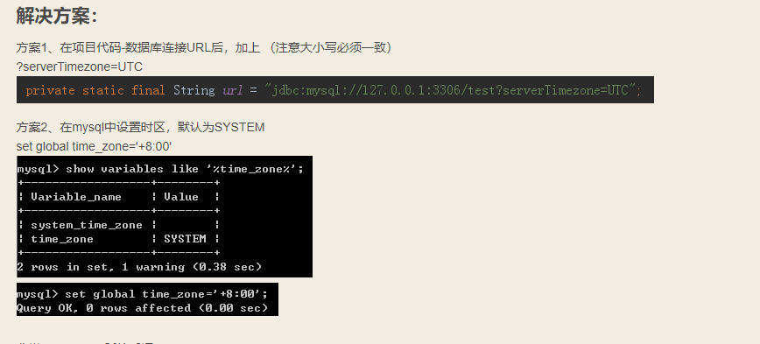





解决方法：

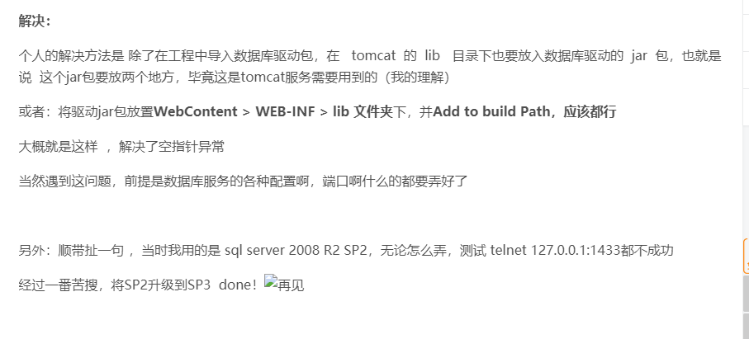

其中将驱动文件放到webcontent/web-inf/lib是好使的。